SEMINAR PROGRAMME 2022 DIPARTIMENTO DI CHIMICA “GIACOMO CIAMICIAN”

Gold Catalysis: Heterocycles, π-Systems, Light

Lunedì 5 Settembre, 2022

Aula Magna - 11:00
LINK TEAMS

Dipartimento di Chimica “Giacomo Ciamician”
Via F. Selmi 2

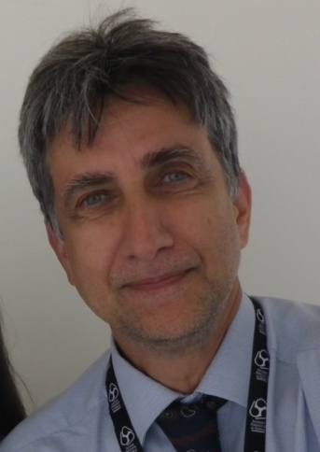

Prof. Stephen HASHMI

Institute of Organic Chemistry
University of Heidelberg

